**Physics 190 Write-Up**

This quarter, I began working with data from the GASKAP-HI telescope in Australia. I began my research by reading many academic astrophysics articles: articles about the H_1 distribution of the Milky Way (Kalberla and Kerp 2009), about the GASKAP-HI data (Pingel et al 2021), and about the GALFA-HI telescope (Peek et al 2018), though I did not end up working with data from GALFA-HI telescope. I also read more about filamentary hydrogen in the Milky Way, and about the phases of the interstellar medium using the *Interstellar and Intergalactic Medium* textbook by Ryden and Pogge. (My notes on this textbook are in my research notes.)

Beyond reading, most of the research I conducted regarded creating plots to probe the GASKAP-HI data more deeply. I began with a FITS cube of the diffuse gas from the Milky Way galaxy on a region of the sky facing towards the Small Magellanic Cloud. The cube depicted the data at various velocities with respect to the Sun, with lighter patches in the data representing filamentary hydrogen at the velocity listed. I remember my initial confusion stemming from the Glue software - Glue “played” the cube’s data as if it were a movie; as you scroll through the data at different velocities, it shows the hydrogen and its filamentary structures, or lack thereof, which, to the amateur researcher, appears as a movie dependent on time. Group meeting helped to correct my misconceptions, and I started optimizing the visibility of this FITS file on Glue.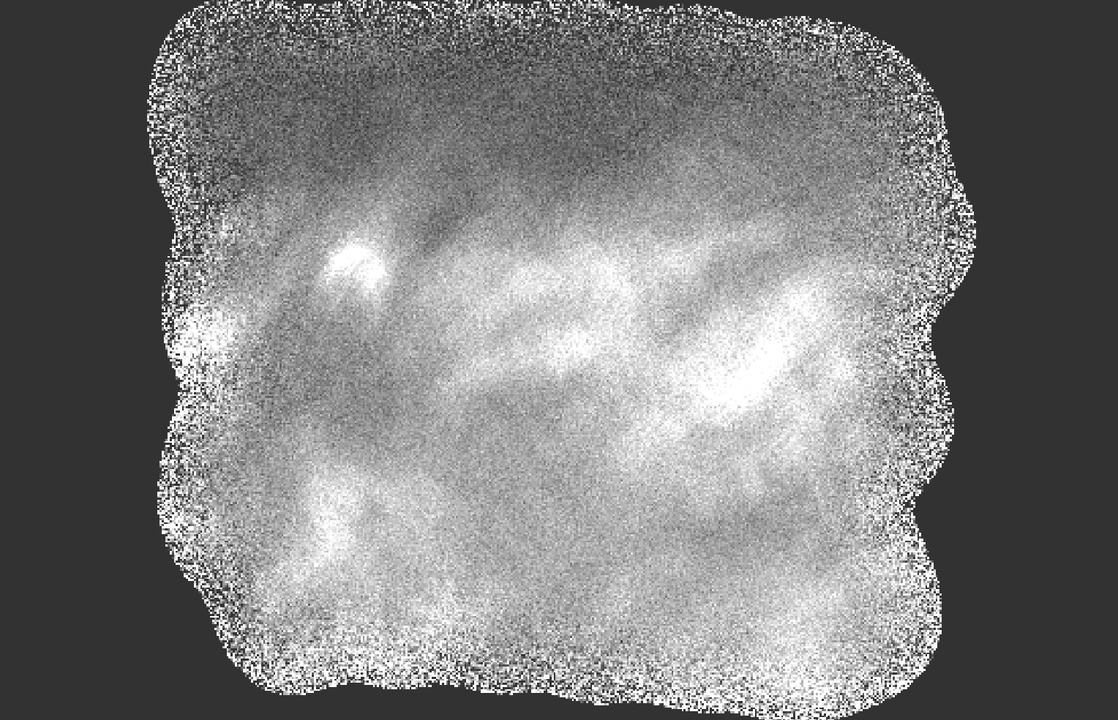

**Figure 1**

I then parsed through the cube and observed at what velocities the filaments appeared (and how they appeared structurally, though this may have included some telescopic error): they seemed to be concentrated between 7.68 km/s and -6.00 km/s.

Around the end of January, I began working with Jupyter Notebook, Astropy, and MatPlotLib to plot the data. (It took many YouTube tutorials to get started.) I started by trying to create plots using the physical png screenshots I took from the cube, but soon ran into problems with the grid lines and their scale. So then I started over, working directly to obtain the specific images I wanted from the FITS file. Here, I ran into another large problem: the images I was obtaining appeared the same at every velocity. The colors were not changing to depict the nuances in the data. (Now I know that this issue was created by not adjusting the stretch of the data.) After many, many frustrated Google searches, we fixed this issue together by adjusting the minimum and maximum velocity displayed on the image, which produced nice plots of the data. Yay!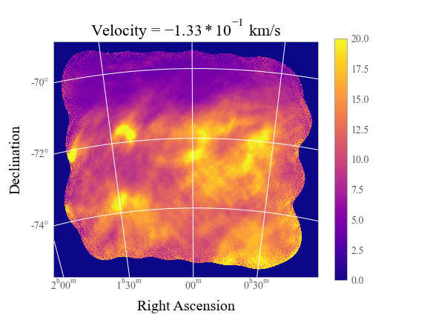

**Figure 2**

Now I moved onto calculating column densities for the neutral hydrogen by integrating the velocity along the Z-axis—but not without reading more papers beforehand. My main takeaways from these papers were that carbon monoxide is a primary tracer for H_2 (Kalberla et al 2020), molecular formation is caused by turbulence and shocks in the interstellar medium (Rybarczyk 2021), and small-scale HI structure is associated with cold-phase material (Peek and Clark 2019).

After integrating the FITS cube over the velocity axis, I plotted the graphs over a variety of column densities, including the column density for the complete range of velocities presented, and for ranges of velocities where there were prominent filamentary structures present.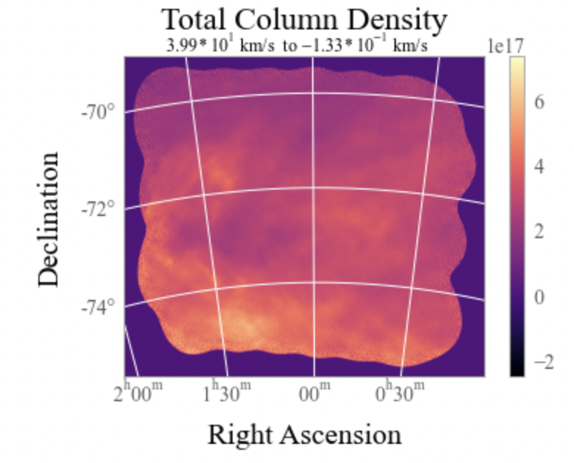

**Figure 3**

The last task I did (as of 2/25/21) involved bringing absorption line data in from background stars in the Small Magellanic Cloud. After familiarizing myself with Pandas, I created a scatterplot of the stars given their position on the sky, with the color increasing in intensity as log10_N_MW increases.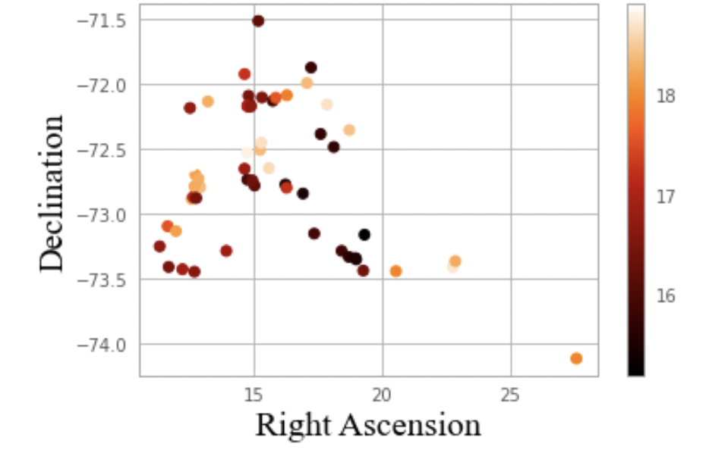

**Figure 4**

I then plotted that scatterplot atop some column density maps: this proved difficult because the axes would not align between the two data sets. After much struggling, I managed to create the plot once I physically assigned world coordinates to each pixel value of the absorption line data: I created a grid of (ra, dec) values corresponding to each pixel, and utilized these coordinates in a plot.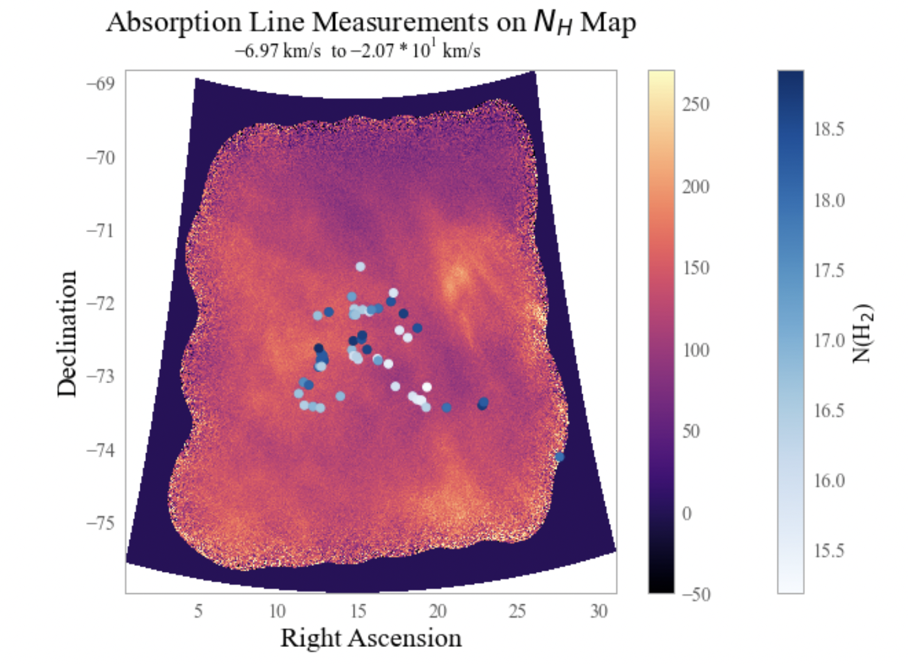

**Figure 5**

My last project of the quarter was to present my investigation of the GASKAP-HI data to the GASKAP-HI Filaments group meeting on March 5th; for that, I picked a few shots from the data above and uploaded it to a [slideshow](https://docs.google.com/presentation/d/1fSiPeIP_4_s609HdNpsGcdmY5vfKPf_se2einH6sXhg/edit?usp=sharing), and then presented said slideshow at the meeting while explaining my methods and conclusions.

Overall, this quarter, I mainly learned *how* to conduct research (and how to present that research to others): how to perform data analysis (and fix subsequent coding problems) and associate quantitative results with qualitative answers. I spent much time simply learning how to use MatPlotLib, AstroPy, FITS cubes, and other tools to my advantage, to extract information such as the column densities and channel maps.

My research this quarter primarily analyzed the properties of hydrogen filaments in the diffuse gas from the Milky Way galaxy near the Small Magellanic Cloud, contributing to greater scientific research as the gas has not been heavily explored in this region. Next quarter, given the absorption line measurements, I hope to discover more about the state and chemistry of the filamentary hydrogen structures of this gas.

**Estimated Time Spent Weekly:** average of about 8 hours - mostly I was just trying out various strategies to get the data I want, and often dealing with errors/“failure.”